CTM-I Use Case

Trade Allocation

Version 0.1

Use Case Name | Trade Allocation
Actor | Firm User, Market Ops, Ops, App Support
Pre-conditions /Assumptions | User has Browser and is aware of the http path to the application.  User has successfully logged into the CTM-I application.  User has the right role to see the menu options.
Post Conditions | None
Screenshot | 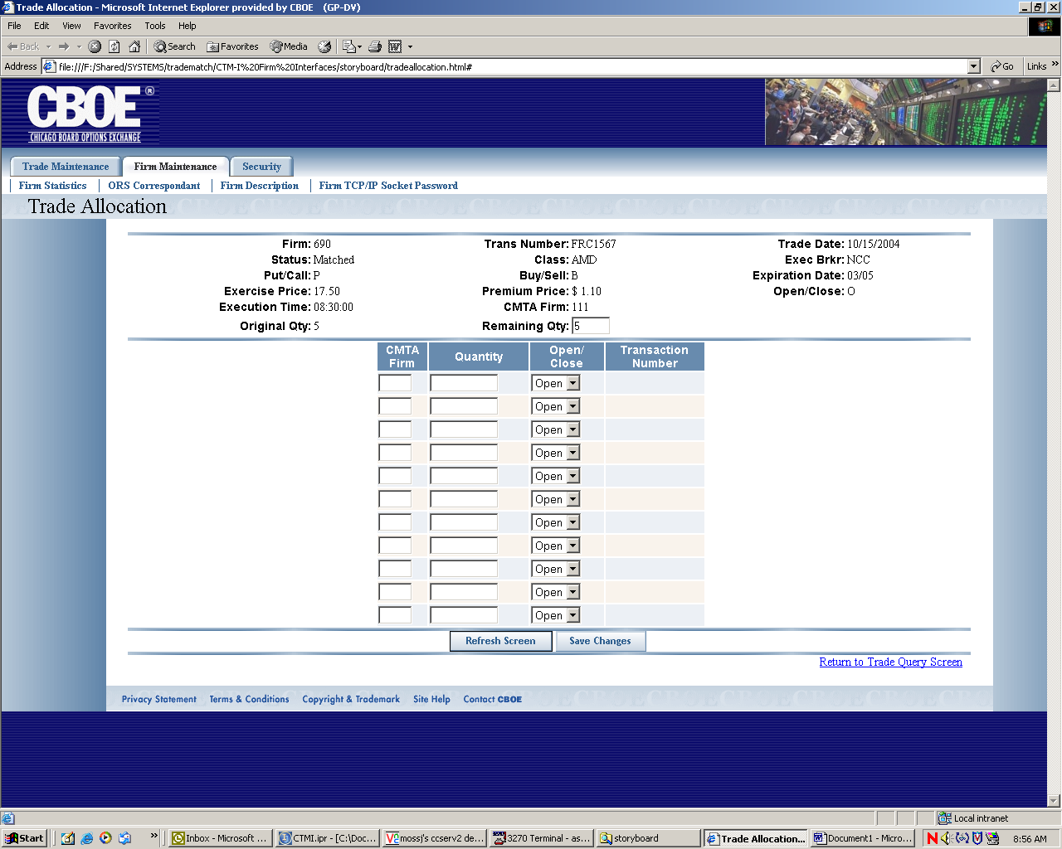
Flow of Events | - User selects “allocation “ from the Trade Query Results screen on selected trade.  - Trade Allocation screen appears  - User enters CMTA firm and quantity and selects open or close from drop down box. User hits enter and quantity remaining to be allocated will appear in “Remaining Qty” box. User must allocate full quantity of trades then hit “Save Changes” which will forward allocations as trade structures to CTMR. CTMR will return new transaction numbers which will display on screen. Screen will not forward info to CTMR until fully allocated. Screen will not allow user to over allocate. Screen will display new Transaction numbers.  4. If there is a problem with the allocations entered user can start all over by hitting the refresh button which will clear all of the allocatioins fields for er-entry.
Alternative Path | - If the system is down and the allocations can not be performed than the system will send a “System down, contact systems support” message to the user

